|  |  |  |  |  |
| --- | --- | --- | --- | --- |
| **Date** | **Location** | **Against** | **Time** | **V/JV** |
| Tuesday, August 14, 2018 | Coosa | Dalton | 6:00 | JV |
| Coosa | 7:00 | JV |
| Thursday, August 16, 2018 | Home | Gordon Central | 5:00 | JV |
| LFO | 7:00 | JV |
| Tuesday, August 21, 2018 | Rome | Rome | 5:00 | JV |
| Cass | 6:00 | JV |
| Tuesday, August 28, 2018 | Pepperell | Gordon Central | 6:00 | JV |
| Pepperell | 7:00 | JV |
| Thursday, August 30, 2018 | Home | Coosa | 5:00 | JV |
| Armuchee | 7:00 | JV |
| Tuesday, September 04, 2018* | Gordon Lee* | Gordon Lee* | 5:00 | JV |
| Thursday, September 06, 2018 | Home | Ridgeland | 5:00 | JV |
| Rome | 7:00 | JV |
| Tuesday, September 11, 2018* | Gordon Central* | Gordon Central* | 5:00 | JV |
| Thursday, September 13, 2018 | Lafayette | Lafayette | 5:00 | JV |
| Dade | 6:00 | JV |
| Thursday, September 20, 2018 | Home | Heritage | 5:00 | JV |
| Pepperell | 7:00 | JV |
| Tuesday, September 25, 2018* | Home* | Dade* | 5:00 | JV |

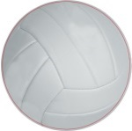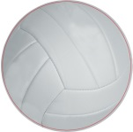**CHATTOOGA VOLLEYBALL 2018**